Visualization and Virtual Environments
The benefits for data analysis have been demonstrated by recent research at VirginiaTech’s Center for Human Computer Interaction (CHCI, http://www.hci.vt.edu/). For example, immersion and high-resolution graphical interfaces (such as the CAVE and the GigaPixel) can have significant performance benefits for analysis and decision-making tasks especially when the data is large or heterogeneous in nature (Raja 2004; Ni 2006; Yost 2006; Bowman 2007).
Visual computing tools facilitate analytical reasoning on large heterogeneous data sets through interactive visual interfaces (Friedhoff 2000). These include graphical user interfaces, virtual environments, information visualization, and augmented reality. Such tools are also known as ‘visual analytics’ tools and enable understanding of complex data such as simulation and numeric computations, data-mining and statistical methods. The development of new visual interfaces that leverage the power of human perception for decision making and discovery is recognized as a priority for further research (C. R. Johnson 2006; Thomas 2006; NAE 2008). We propose to advance the utility and usability of TeraGrid tools through basic research in immersive and collaborative visualization in integrated information spaces.
This research has significant intellectual merit due to its new model of distributed computation and service-based visualization. The proposed framework extends international web standards, visualization tools and network protocols to enable remote and collaborative work. Based on user tasks and interactions, the system adapts its rendering and composition pipeline, and the user interface to deliver information-rich environments on demand and at interactive frame rates.

Information Visualization

High-Res, Large-Format Displays
Senior Personnel: Amitabh Varsheny

<AMITABH ‘s parts here >

Virtual Environments

Benefits of Immersion
Senior Personnel: Doug Bowman

3D scientific visualization using virtual reality (VR) technologies has become common in academic research laboratories, and in some industrial settings as well. But there is inevitably a question of cost-benefit: does the use of an immersive VR system, such as a CAVE, provide enough additional insight, efficiency, or accuracy to justify the much-higher cost of its use? Could we receive a large percentage of this benefit by simply upgrading the researcher's desktop (e.g., with a stereoscopic monitor or with multiple tiled displays)? The VR research community has not yet provided answers to these questions on the whole. Our research agenda is to evaluate the effects of immersion on a component-by-component basis, for a range of user tasks and application areas (Bowman 2007). In other words, we aim to determine the effects of components such as wide field of view, stereoscopy, and head tracking (and all the combinations of such components) on measurable outcomes such as spatial understanding, visual search efficiency, or navigation accuracy. To date, we have run dozens of experiments and have learned a great deal about the effects of immersion,especially for understanding of complex 3D scenes (Bowman 2004; Narayan 2005; Polys 2005c; McMahan 2006; Wang 2007).

Our work on the effects of immersion has been quite successful, but has also been limited by the maximum level of immersion possible in current display systems. The research has made use of the CAVE at Virginia Tech, which is capable of a wide field of view, moderate field of regard, stereo, and head tracking, but which is also very limited in terms of resolution, brightness, and 360-degree surround. Being able to evaluate the effects of much higher levels of immersion using the proposed infrastructure would allow us to understand the effects of immersion more fully. The proposed equipment would allow us to simulate actual displays ranging from a typical laptop monitor up to extremely high-end VR systems, and everything in between. Thus, controlled experiments on the effects of immersion would have more generalizable and useful results.

Multi-User Virtual Environments
Senior Personnel: Denis Gracanin

Multi-user virtual environments, computer games and related applications are more and more focusing on collaborative aspects, be it a collaborative engineering design, education or gaming (Zyda 2005). While visual analysis is primarily a single-user activity, the increasing scale and complexity of data sets necessitate the support multi-user, collaborative visualization. Collaboration among multiple users brings together different and diverse expertise, experience and insights. Designing collaborative visualization applications require novel methods of presentation, interaction, and sharing. We can leverage experiences from the current revolution in video-gaming and its application both for entertainment and serious purposes (Zyda 2006).

Designing visualization tools involve a combination of off-line and real-time simulation with the existing data sets to to realize a tightly coupled steering loop, integrating new simulation technology and interactive visual analysis (Matković 2008). The well-known techniques like multiple coordinate views, composite brushing and focus+content (Konyha 2006) lend themselves to a distributed, multi-user framework. Collaborative visualization is a dynamic process where the users need not to be "together" all the time. Instead a truly flexible and interactive collaborative visualization should allow users to split into ad-hoc groups that change in number and size. A networking infrastructure based on the results from game engine development can be constructed from off-the-shelf component in an efficient and cost-effective way. With the anticipated move to IPV6, such an infrastructure can then take advantage of IPV6 QoS mechanisms (real-time support and flows), security, routing and addressing (multicast and anycast groups) (Huitema 1998).

Information-Rich Virtual Environments
Nicholas Polys (Visualization Research Team Lead)

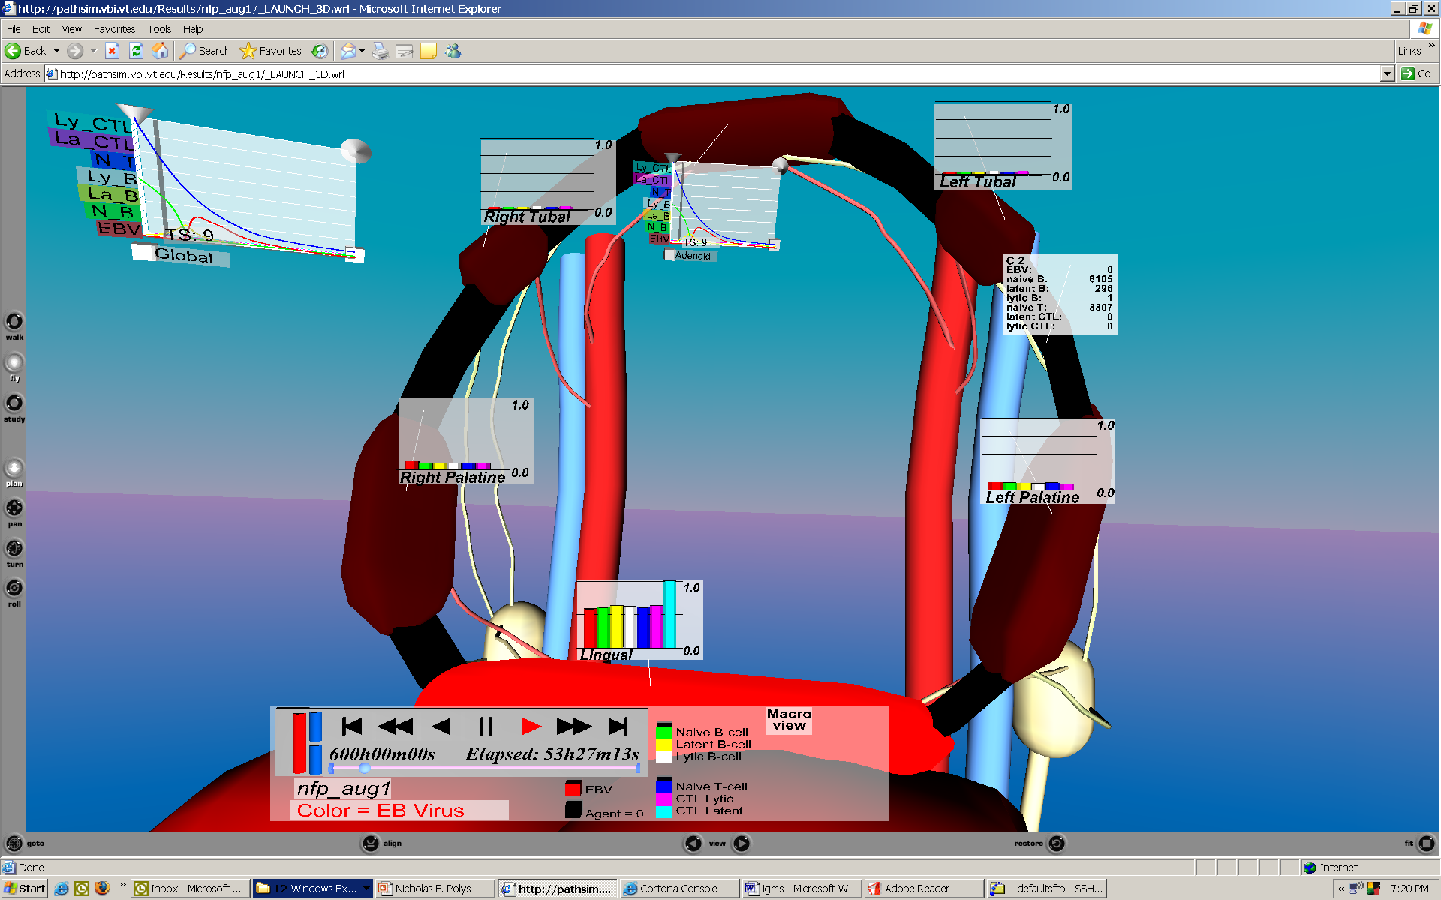
The canonical virtual environment (VE) application is the walkthrough – a three-dimensional world made up of geometry, colors, textures, and lighting. Walkthroughs contain purely perceptual information – that is, they match the appearance of a physical environment as closely as possible. In traditional information visualization applications, on the other hand, the environment contains purely abstract information that has been mapped to perceptual dimensions such as position, shape, size, or color. We propose to extend a new research area at the intersection of traditional VEs and traditional information visualization: Information-rich virtual environments (IRVEs) start with realistic perceptual information and enhance it with related abstract information (Bowman et al, 2003).
Figure X: Multi-scale IRVE layout techniques applied to agent-based immune system simulation results - from (M. Shapiro 2008)

IRVEs can be applied to a wide variety of domains because the relationships and links between abstract and perceptual information that are common in the real world. For example, an architect is interested not only in the aesthetic qualities of her design (perceptual information), but also in building materials, dimensions, and costs (abstract information). A physics student benefits from both equations (abstract) and observation (perceptual). IRVEs seek to present both types of information, making clear the relationships within and between them. Because scientists are attempting to extend existing knowledge, they do not always know what they are looking for. As a consequence, the necessary ingredients for analysis and discovery may not be known a priori. Visualization tools must be flexible enough to support opportunistic questions and hypotheses with little specialized modification.
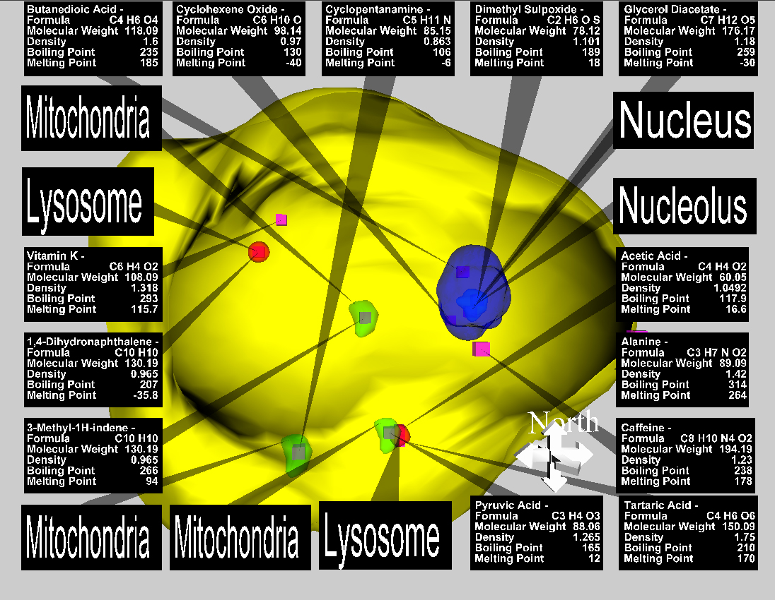
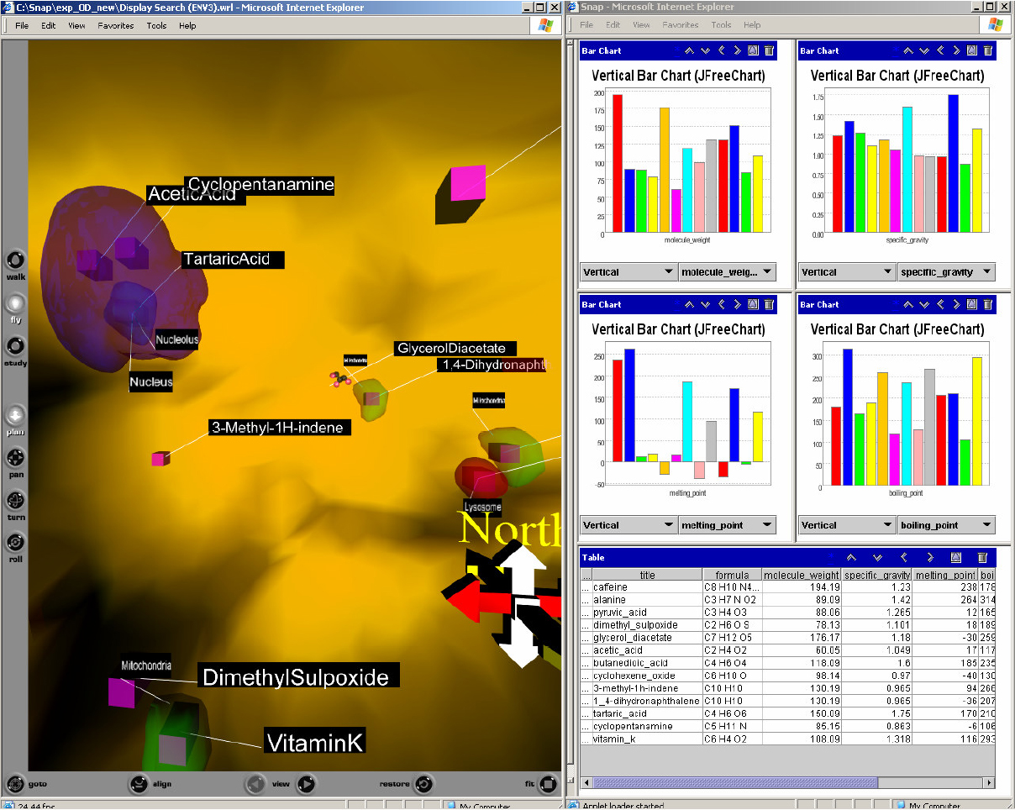
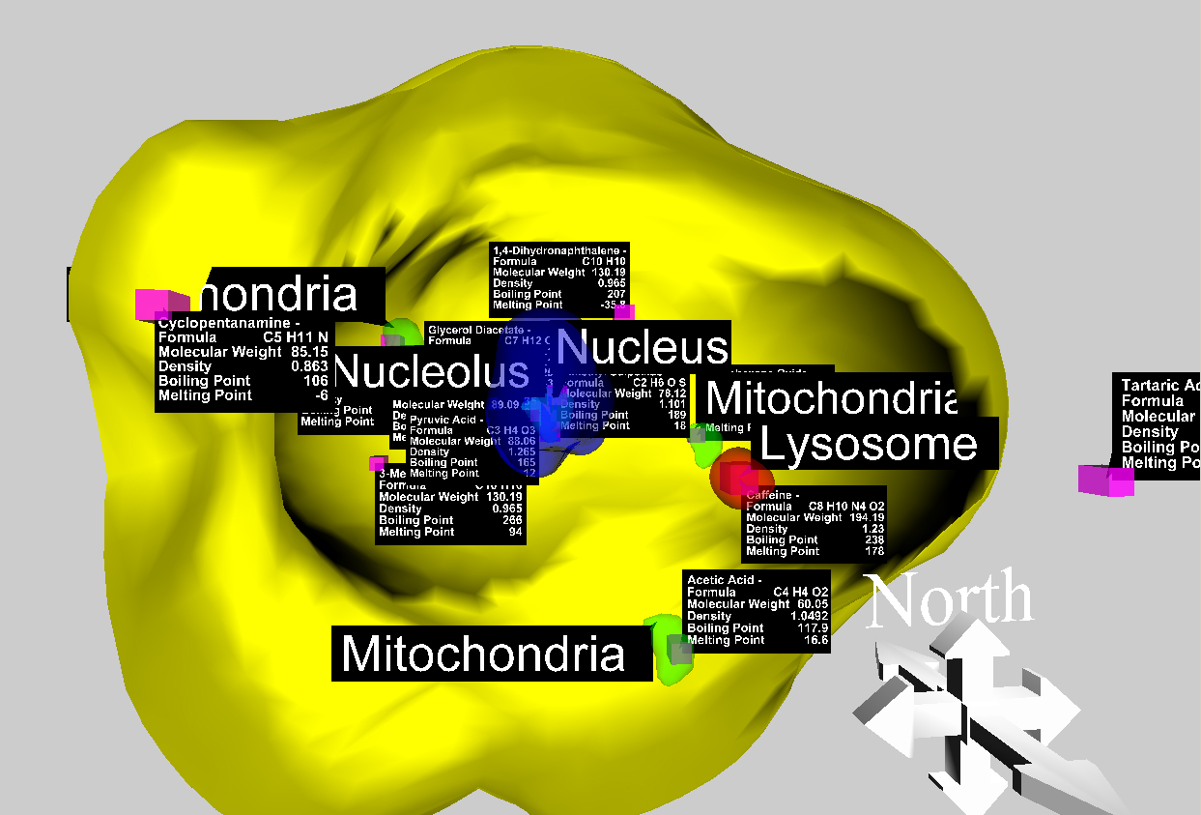
Figure X: Equivalent data sets rendered with different dynamic IRVE layout techniques
We have strong foundations for this research. For example, we have examined the information transmission value of specific combinations of Depth and Gestalt Cues in IRVE layouts (Figures X, X). A number of empirical results have emerged that provide a basis for design guidelines and for further research. For different tasks (such as search or comparison), information criteria and targets (spatial, abstract, temporal types), and display sizes (desktop to walls), users rely on different combinations of perceptual cues to integrate disparate information types. The configurations of visual information have significant impact on user performance and satisfaction. (Polys 2006).

It is clear that the computational cycles and network resources devoted to data transformation, rendering and sharing can be optimized for the human user. We have deployed a standards-based (ISO), web middleware framework that implements these mappings for IRVE representations for large data across scales (e.g.(Polys 2003; Polys 2004d; Polys 2007)). Such a gateway for delivering interactive visualizations across the web can be used to cross the digital divide and serve our rural citizens and schools. Such a delivery mechanism for communicating and experiencing science is essential to advancing specific fields and the STEM strategy of education for American competitiveness.

